CDAC MUMBAI

# Concepts of Operating System Assignment 1

**Problem 1: Read the instructions carefully and answer accordingly. If there is any need to insert some data then do that as well.**

## Navigate and List:

* 1. Start by navigating to your home directory and list its contents. Then, move into a directory named "LinuxAssignment" if it exists; otherwise, create it.
* **Command:**

**cdac@LAPTOP-02EB1MBV:~$ pwd**

**/home/cdac**

**cdac@LAPTOP-02EB1MBV:~$ mkdir LinuxAssignment**

**cdac@LAPTOP-02EB1MBV:~$ cd LinuxAssignment**

**cdac@LAPTOP-02EB1MBV:~/LinuxAssignment$ ls**

**cdac@LAPTOP-02EB1MBV:~/LinuxAssignment$ ls -l**

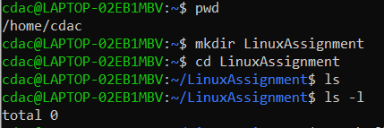

## File Management:

* 1. Inside the "LinuxAssignment" directory, create a new file named "file1.txt". Display its contents.
* **Command:**

**cdac@LAPTOP-02EB1MBV:~/LinuxAssignment$ touch file1.txt**

**cdac@LAPTOP-02EB1MBV:~/LinuxAssignment$ ls -l**

**total 0**

**-rw-rw-r-- 1 cdac cdac 0 Aug 29 12:23 file1.txt**

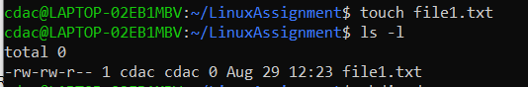

## Directory Management:

* 1. Create a new directory named "docs" inside the "LinuxAssignment" directory.
* **Command:**

**cdac@LAPTOP-02EB1MBV:~/LinuxAssignment$ mkdir docs**

**cdac@LAPTOP-02EB1MBV:~/LinuxAssignment$ ls -l**

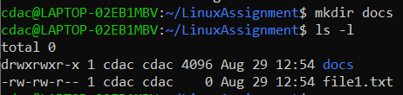

## Copy and Move Files:

* 1. Copy the "file1.txt" file into the "docs" directory and rename it to "file2.txt".

**Command:**

cdac@LAPTOP-02EB1MBV:~/LinuxAssignment$ cp file1.txt docs

cdac@LAPTOP-02EB1MBV:~/LinuxAssignment$ ls

docs file1.txt

cdac@LAPTOP-02EB1MBV:~/LinuxAssignment$ cd docs

cdac@LAPTOP-02EB1MBV:~/LinuxAssignment/docs$ ls

file1.txt

cdac@LAPTOP-02EB1MBV:~/LinuxAssignment/docs$ mv file1.txt file2.txt

cdac@LAPTOP-02EB1MBV:~/LinuxAssignment/docs$ ls -l

total 0

-rw-rw-r-- 1 cdac cdac 0 Aug 29 13:33 file2.txt

cdac@LAPTOP-02EB1MBV:~/LinuxAssignment/docs$ ls

file2.txt

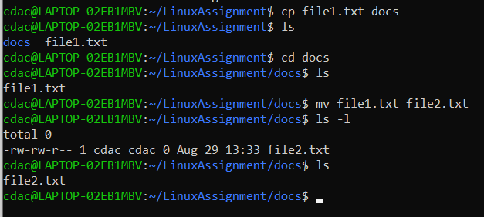

## Permissions and Ownership:

* 1. Change the permissions of "file2.txt" to allow read, write, and execute permissions for the owner and only read permissions for others. Then, change the owner of "file2.txt" to the current user.

**Command:**

**cdac@LAPTOP-02EB1MBV:~/LinuxAssignment/docs$ chmod u+rwx file2.txt**

**cdac@LAPTOP-02EB1MBV:~/LinuxAssignment/docs$ ls -l**

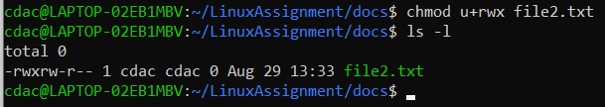

## Final Checklist:

* 1. Finally, list the contents of the "LinuxAssignment" directory and the root directory to ensure that all operations were performed correctly.

**Command:**

**ls -l ,**

**or**

**ls -l ~/LinuxAssignment**

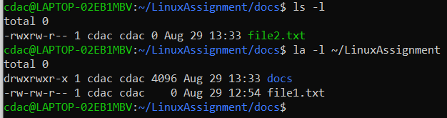

**the root directory:**

**commands: ls -l /**

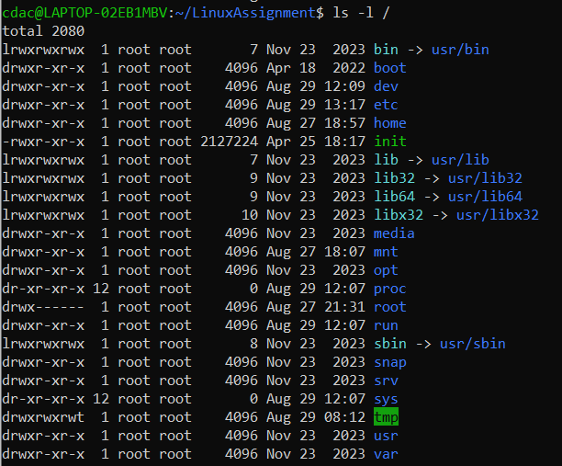

## File Searching:

* 1. Search for all files with the extension ".txt" in the current directory and its subdirectories.

**Command:**

**find . -type f -name "*.txt"**

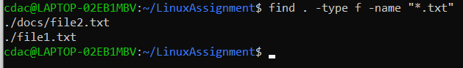

* 1. Display lines containing a specific word in a file (provide a file name and the specific word to search).

**Command:**

**grep "Shweta" file1.txt**

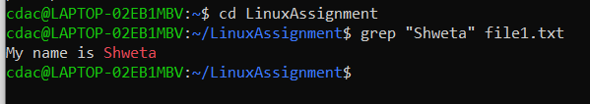

## System Information:

* 1. Display the current system date and time.

**Command: date**

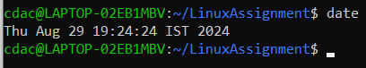

## Networking:

* 1. Display the IP address of the system.

**Command: ip a**

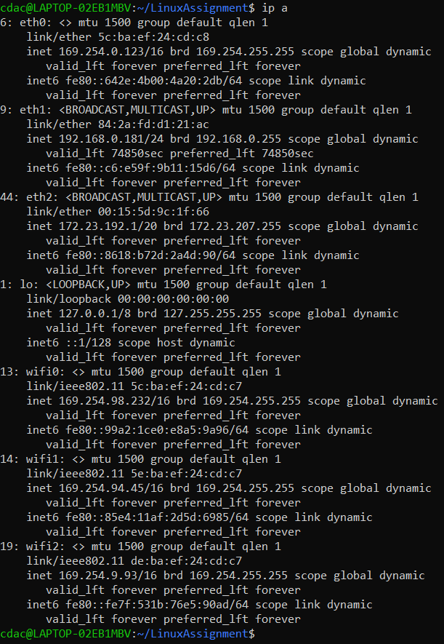

* 1. Ping a remote server to check connectivity (provide a remote server address to ping).

**Command**:

**cd LinuxAssignment**

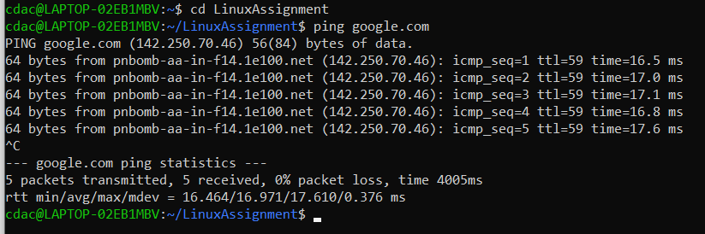

## File Compression:

* 1. Compress the "docs" directory into a zip file.

**Command: zip -r docs2.zip docs2**

* 1. Extract the contents of the zip file into a new directory.

**Command: unzip docs2.zip**

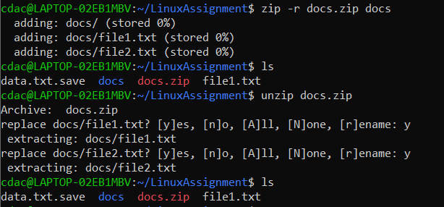

## File Editing:

* 1. Open the "file1.txt" file in a text editor and add some text to it.

**Command:**

**nano file1.txt**

* 1. Replace a specific word in the "file1.txt" file with another word (provide the original word and the word to replace it with).

**Command:**

**sed -i 's/Good/Morning/g' file1.txt**

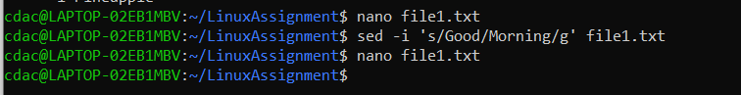

# Problem 2: Read the instructions carefully and answer accordingly. If there is any need to insert some data then do that as well.

1. Suppose you have a file named "data.txt" containing important information. Display the first 10 lines of this file to quickly glance at its contents using a command.

**Command: nano data.txt**

**head -10 data.txt**

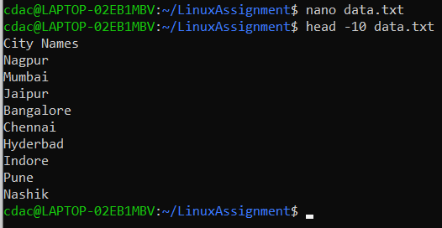

1. Now, to check the end of the file for any recent additions, display the last 5 lines of "data.txt" using another command.

**Command:**

**tail -5 data.txt**

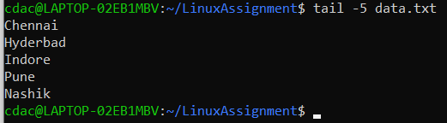

1. In a file named "numbers.txt," there are a series of numbers. Display the first 15 lines of this file to analyze the initial data set.

**Commands :**

**nano numbers.txt**

**Head -15 numbers.txt**

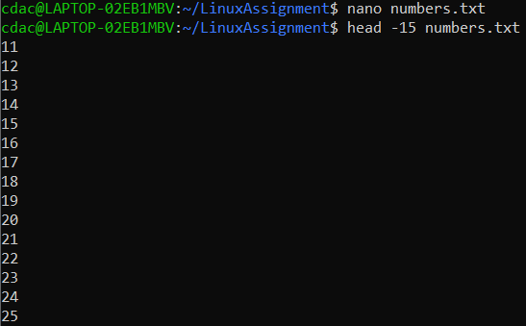

1. To focus on the last few numbers of the dataset, display the last 3 lines of "numbers.txt".

**Command:**

**tail -3 numbers.txt**

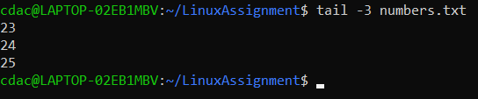

1. Imagine you have a file named "input.txt" with text content. Use a command to translate all lowercase letters to uppercase in "input.txt" and save the modified text in a new file named "output.txt."

**Command:**

**cdac@LAPTOP-02EB1MBV:~/LinuxAssignment$ nano input.txt**

**cdac@LAPTOP-02EB1MBV:~/LinuxAssignment$ touch output.txt**

**cdac@LAPTOP-02EB1MBV:~/LinuxAssignment$ tr 'a-z' 'A-Z' < input.txt > output.txt**

**cdac@LAPTOP-02EB1MBV:~/LinuxAssignment$ nano output.txt**

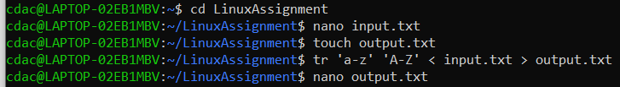

1. In a file named "duplicate.txt," there are several lines of text, some of which are duplicates. Use a command to display only the unique lines from "duplicate.txt."

**Commands:**

**cdac@LAPTOP-02EB1MBV:~/LinuxAssignment$ nano dublicates.txt**

**cdac@LAPTOP-02EB1MBV:~/LinuxAssignment$ sort dublicates.txt**

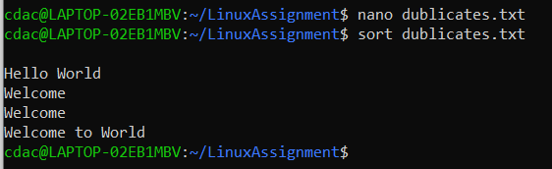

1. In a file named "fruit.txt," there is a list of fruits, but some fruits are repeated. Use a command to display each unique fruit along with the count of its occurrences in "fruit.txt."

**Commands:**

**cdac@LAPTOP-02EB1MBV:~/LinuxAssignment$ nano fruits.txt**

**cdac@LAPTOP-02EB1MBV:~/LinuxAssignment$ sort fruits.txt | uniq -c**

